FAULT DENSITY and other data | Abstract  Fault density is one of the important indicators for geothermal site exploration. For that reason, we have used available fault lines for Brady, Desert Peak and Salton Sea geothermal fields. We apply line density function to create a density map. This density maps are input for SOM, SVM and Artificial Intelligence (AI) algorithm. Moreover, we explained some other auxiliary data that we used for comparison and verification.  10/28/2020

Contents
1. INTORDUCTION 1
2. DATA 2
2.1. Wells’ Data and Area Of Interest (AOI) 3
2.1.1. Brady Wells’ Data and Extent AOI 3
2.1.2. Desert Peak Wells and Extent of AOI 5
2.1.3. Salton Sea Wells’ Data and Extent 8
2.2. Fault Data 9
2.2.1. Fault for Brady 9
2.2.2. Fault for Desert Peak 12
2.2.3. Fault for Salton Sea 14
2.3. Seismic Data for Brady 15
2.4. DTS Data for Brady 17
3. RESULTS and CONCLUSION 19
REFERENCES 19

- INTORDUCTION
Fault is one of the complementary indicators for exploration of the geothermal with several other indicators such as displacement, land surface temperature (LST), mineral maps. Therefore, fault data for the selected three geothermal fields (e.g. Brady, Desert Peak and Salton Sea) is another and important indicator (Morphology Literature, 2019) for Artificial Intelligence (AI) algorithm. Active faults create a pathway for hot fluid (Villamor et al., 2015). Therefore, faults and geothermal fields have strong relations. Additionally, porosity, permeability, fluid flow, etc. are key geochemical features for geothermal sources (Moeck, 2014). Moreover, there several researches defining the direction of the faults in different geothermal sites. They claim that northeast-striking faults are observed in geothermal sites predominantly (Minster & Jordan 1987; P´erouse & Wernicke, 2017). The same NEE fault is observed in two of the fields which are Brady and Desert Peak (Benoit et al. 1982; Faulds et al. 2010b; Jolie et al. 2015). These fractures affect the distribution and flow of hot fluids at Brady Hot Spring (Laboso & Davatzes, 2016). Therefore, we assume that there is a relationship between fracture patterns and drainage so does with geothermal field. Therefore, we used fault density as an input for AI.
In addition to those indicators data, we have been used different type of data in order to understand the geothermal fields, the relation with the analysis results. They may not be used directly as a layer for SOM, SVM and AI but they are useful to compare, validate and understand the other analysis indirectly. Therefore, these data are helpful to continue for further analysis that we applied to other layers. These are wells locations, Brady's Geothermal Field Distributed Temperature Sensing Data (DTS), seismic data for Brady. We have used ArcMap 10.5 for analysis of the faults layer and for visualization.
We explained the faults data and related information for Brady, Desert Peak and Salton Sea in the following subsections. In addition to that, we explained the other auxiliary data which are useful for analysis, verification and comparison.

- DATA
  - Wells’ Data and Area Of Interest (AOI)
    - Brady Wells’ Data and Extent AOI
Brady and Desert Peak wells’ location contains x and y coordinates including elevations. Source data for x/y locations used includes Bradys_Master_Porotomo_2015-1-13.xlsx provided by ORMAT as well as coordinates measured by Neal Lord on 3/24/2016 using RTK GPS (Lim, 2016). Land surface elevations are given as m above WGS84 ellipsoid/UTM Zone 11 S. Table 1 shows the wells coordinate metadata in more detail. Brady and Desert Peak Geothermal wells data can be downloaded from https://gdr.openei.org/submissions/828 .
Table 1. Brady and Desert Peak Well Coordinate Metadata
Well Name | Activity during PoroTomo Testing | X | Y | Land Surf Elev (m above WGS84 Ellipsoid) | Position Source
18B-31 | Inj | 328789.6 | 4408711 | 1253.65 | points160324ll_wells.txt
18D-31 | Inj | 328750.1 | 4408630 | 1252.34 | points160324ll_wells.txt
73-25 | Inj | 328181.3 | 4401656 | 1232.47 | Bradys_Master_Porotomo_2015-1-13.xlsx
81A-1 | Inj | 328604.5 | 4408552 | 1248.3 | points160324ll_wells.txt
81-1 | Obs (GPS) | 328562 | 4408507 | 1245.67 | Bradys_Master_Porotomo_2015-1-13.xlsx
56A-1 | Obs (Kuster) | 327857.7 | 4407556 | 1227.87 | points160324ll_wells.txt
81B-1 | Obs (MadgeTek) | 328527 | 4408432 | 1246.05 | points160324ll_wells.txt
SP-2 | Obs (MadgeTek) | 328126.3 | 4407628 | 1236.07 | points160324ll_wells.txt
56-1 | Obs (Vertical DAS) | 327961.9 | 4407555 | 1230.27 | points160324ll_wells.txt
18-1 | Pumping | 327024.7 | 4407033 | 1223.5 | points160324ll_wells.txt
27-1 | Pumping | 327254.3 | 4407205 | 1222 | points160324ll_wells.txt
47C-1 | Pumping | 327745.3 | 4407309 | 1227 | points160324ll_wells.txt
48A-1 | Pumping | 327703.9 | 4407182 | 1226.4 | points160324ll_wells.txt
82A-11 | Pumping | 326904.9 | 4406708 | 1220.59 | points160324ll_wells.txt
46-1 | None | 327805 | 4407485 | 1229.82 | Bradys_Master_Porotomo_2015-1-13.xlsx
BCH-7 | None | 328067.2 | 4401357 | 1224.95 | Bradys_Master_Porotomo_2015-1-13.xlsx
BCH-10 | None | 327913.8 | 4401962 | 1231.8 | Bradys_Master_Porotomo_2015-1-13.xlsx

Figure 1 shows the Wells’ locations for Brady with Area Of Interest (AOI). There are 17 inj, obs, none and pump labelled wells but 13 of them are in AIO.
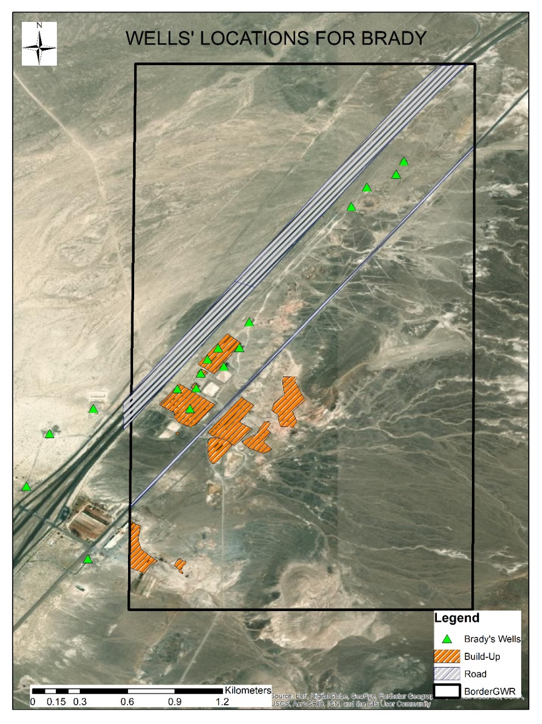
Figure 1. Wells’ Locations for Brady with AOI.

The extent of AOI was created with respect to smallest indicator data that we had or produced. That was why the data which had the smallest border restrict us to study in larger areas in these three geothermal fields. As it is shown that the black rectangle define the extent for Brady geothermal field although we have some more wells outside of this border in Figure 1. Metadata of this border is shown in Table 2.
Table 2. Metadata of Brady AOI.
Data Type | Shapefile Feature Class
Geometry Type | Polygon
Projected Coordinate System | WGS_1984_UTM_Zone_11N
Projection | Transverse_Mercator
Linear Unit | Meter
Geographic Coordinate System | GCS_WGS_1984
Datum | D_WGS_1984
Top | 4409353.218412 m
Bottom | 4405876.347770 m
Left | 327385.104985 m
Right | 329148.000013 m

    - Desert Peak Wells and Extent of AOI
Since the meta information is the same with the Brady wells. We did not explain the data and metadata here again. There are 11 inj, obs, none and pump labelled wells but 10 of them are in AIO. Figure 2 shows the Wells’ locations for Desert Peak with AOI.
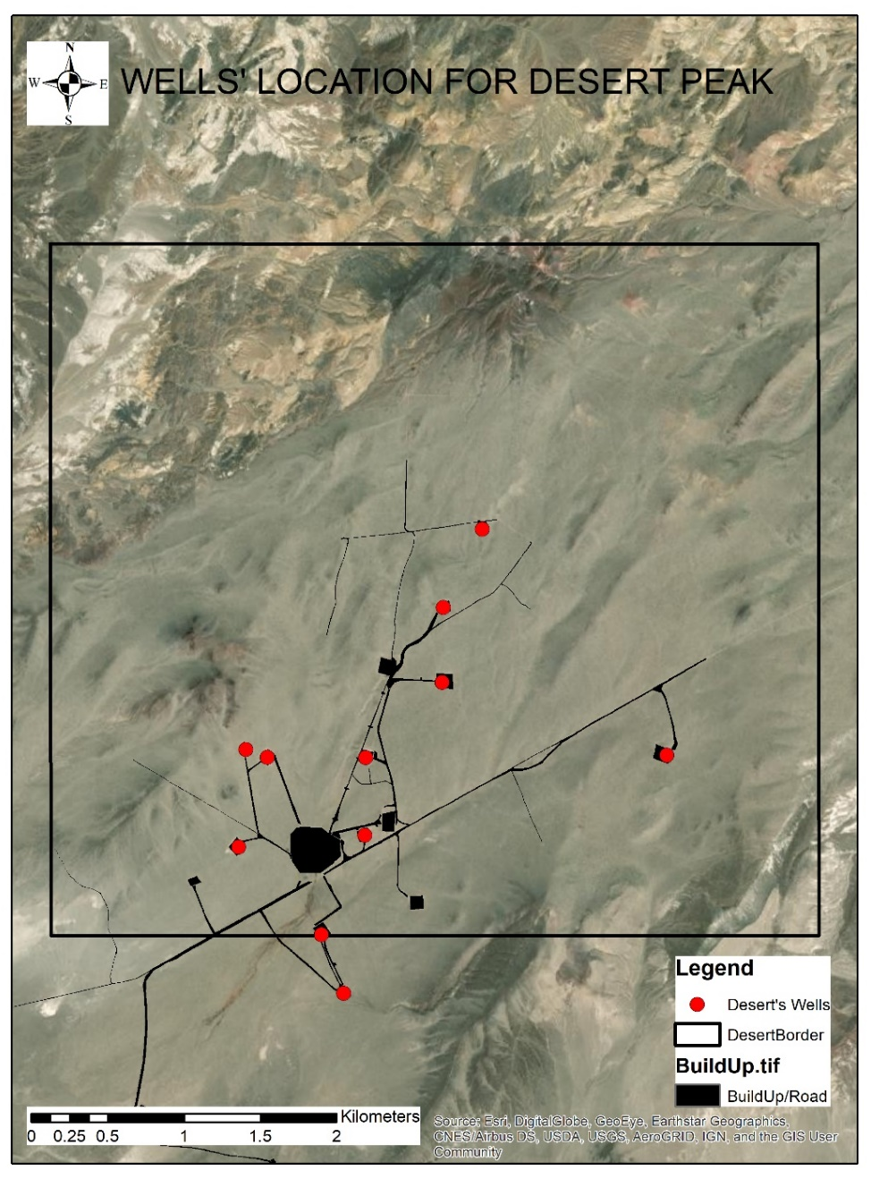
Figure 2. Wells’ Locations for Brady with AOI.

As it is shown that the black rectangle defines the extent for Desert Peak geothermal field although we have some more wells outside of this border in Figure 2. Metadata of this border is shown in Table 2.

Table 3. Metadata of Desert Peak Extent
Data Type | Shapefile Feature Class
Geometry Type | Polygon
Projected Coordinate System | WGS_1984_UTM_Zone_11N
Projection | Transverse_Mercator
Linear Unit | Meter
Geographic Coordinate System | GCS_WGS_1984
Datum | D_WGS_1984
Top | 4406210.844738 m
Bottom | 4401680.409769 m
Left | 330955.339349 m
Right | 335989.790723 m

    - Salton Sea Wells’ Data and Extent

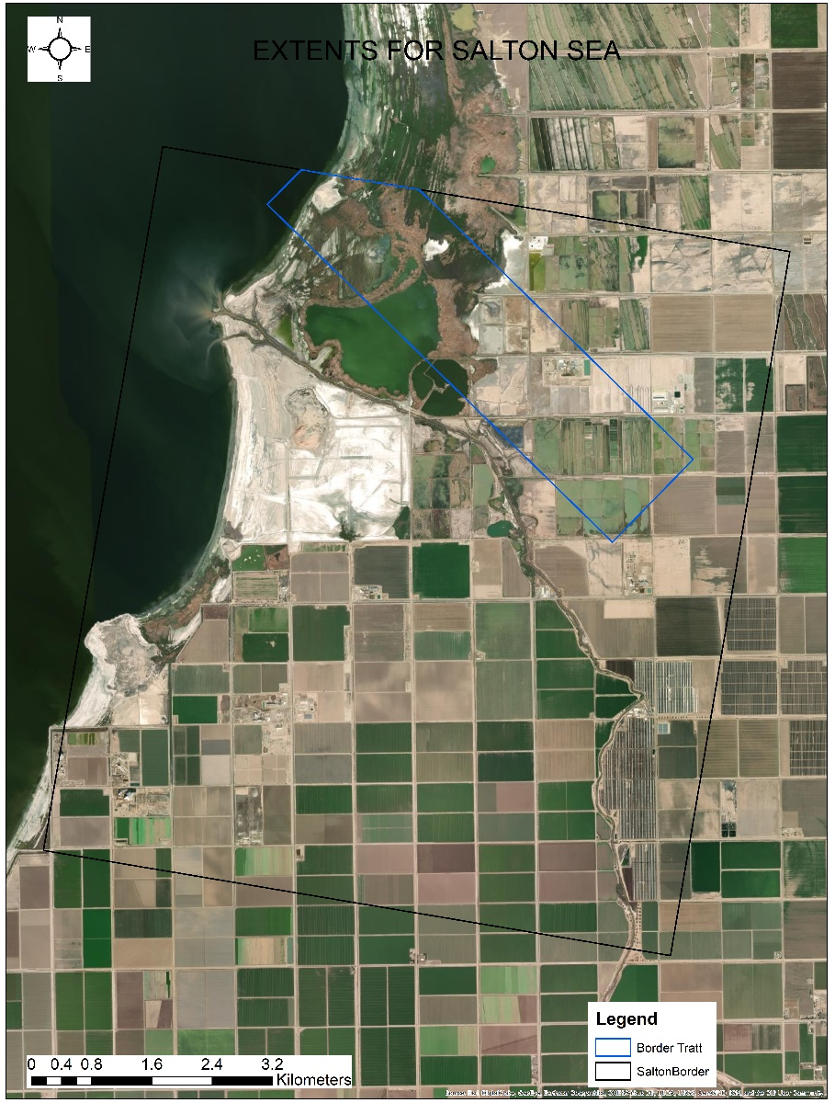
Figure 3. Salton Sea Extent
As it is shown that the black rectangle define the extent for Salton Sea geothermal field in Figure 3. Metadata of this border is shown in Table 4.

Table 4. Metadata of Salton Sea Extent
Data Type | Shapefile Feature Class
Geometry Type | Polygon
Projected Coordinate System | WGS_1984_UTM_Zone_11N
Projection | Transverse_Mercator
Linear Unit | Meter
Geographic Coordinate System | GCS_WGS_1984
Datum | D_WGS_1984
Top | 3677772.384236 m
Bottom | 3667036.776140 m
Left | 625906.840600 m
Right | 635817.427486 m

Although we have larger extent for LST and displacement maps, we have Tratt’s mineral markers map extent which does not cover whole the geothermal field. Table 5 shows the extent of the Tratt’s border and the rest of the metadata is the same as with the larger extent.
Table 5. Tratts’ Mineral Markers Extent for Salton Sea
Data Type | Shapefile Feature Class
Top | 3677464.281333 m
Bottom | 3672522.389241 m
Left | 628878.056051 m
Right | 634534.005749 m

  - Fault Data
As it is mentioned before at the introduction section, fault is another important indicator that should be explained in more detail. We have the faults data for selected three geothermal fields. We explained how to analyze and use them in this section.

    - Fault for Brady
Figure 4 shows faults line for Brady with AOI. We digitized the data from a research carried out previously (Ali et al., 2016). After digitization of the data, we applied line density function to produce a fault density map.
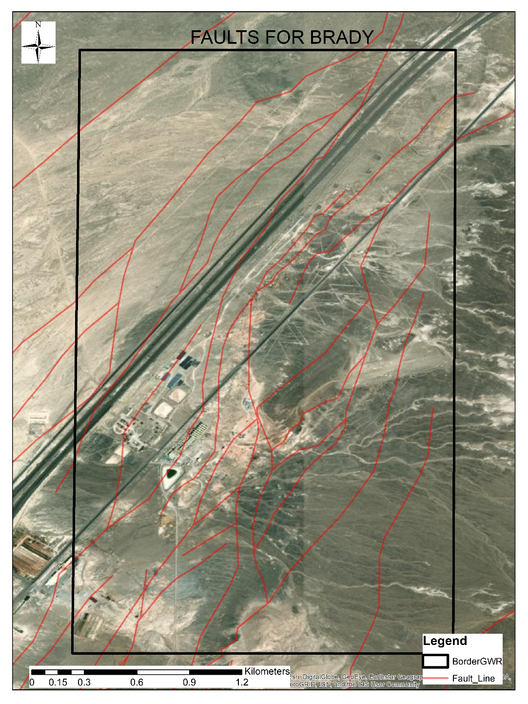
Figure 4. Fault Lines for Brady with AOI.

Figure 5 shows how the line density works in ArcGIS. It creates a circular neighborhood and defined raster cell in order to create a line density map (ArcGIS for Desktop, 2020).
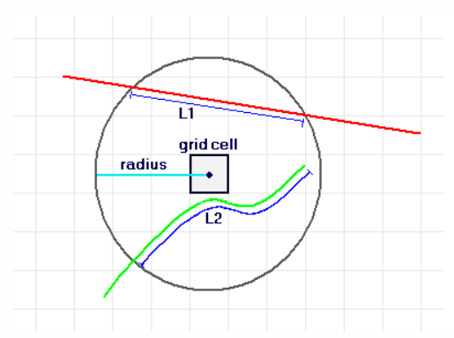
Figure 5. Line Density Map Calculation.
Equation 1 shows the basic calculation of the line density map.
Density = ((L1*V1) + (L2*V2)) / (area_of_circle) (1)

Finally, we got the density map for faults line by applying line density function in ArcGIS. We used this layer as an input for SOM, SVM and AI algorithms. We just defined two things to get density map:
- Cell size of output: 3x3 m
- Circle: 300 m
Figure 6 shows the fault density for Brady. Higher density area is shown with hot colors (red color).
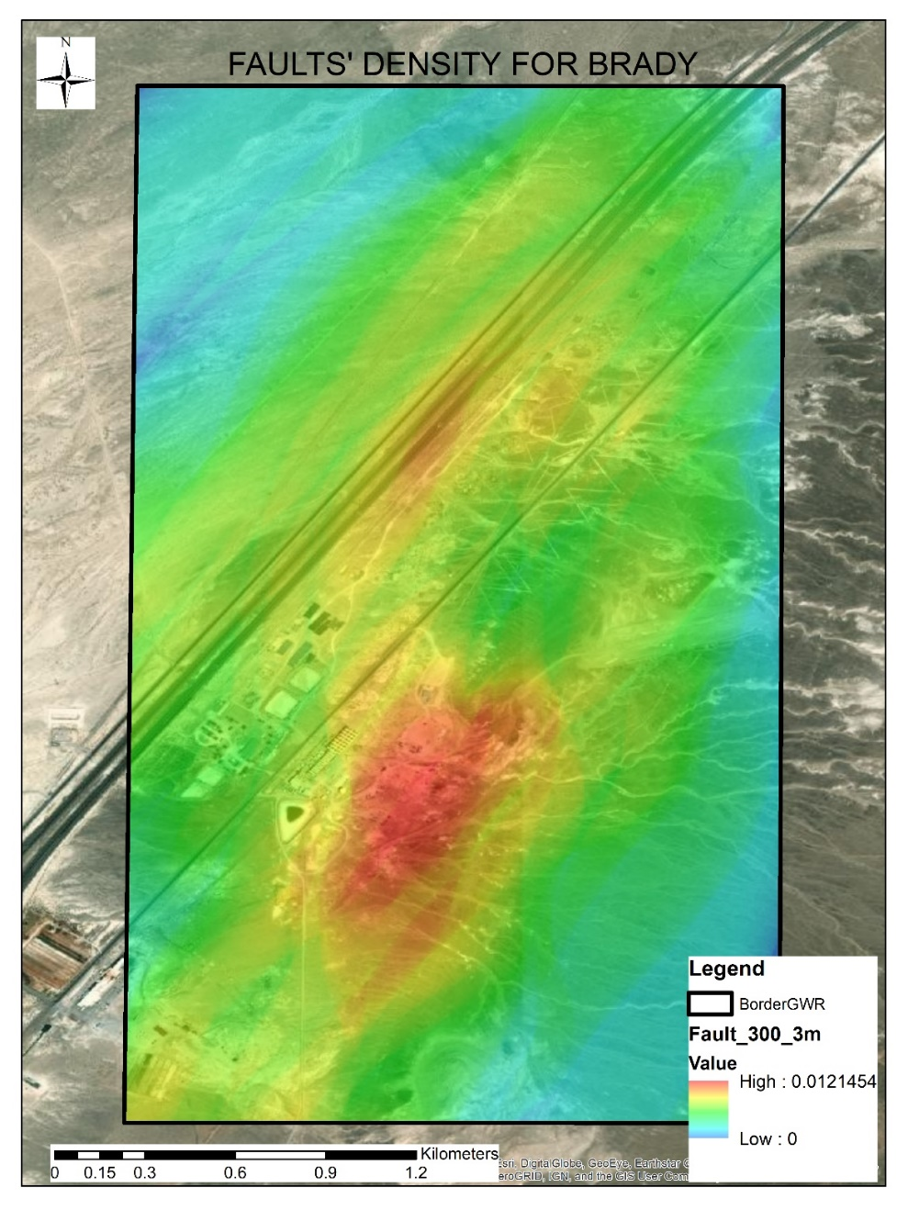
Figure 6. Fault Density for Brady.

    - Fault for Desert Peak
Figure 7 shows fault lines for Desert Peak with AOI. After digitization of the data, we applied line density function to produce a fault density map. We downloaded pdf document from https://data.nbmg.unr.edu/public/freedownloads/geospatial-pdf/OF2003-27_plate.pdf website. Then we digitize the fault lines for Desert Peak geothermal field.
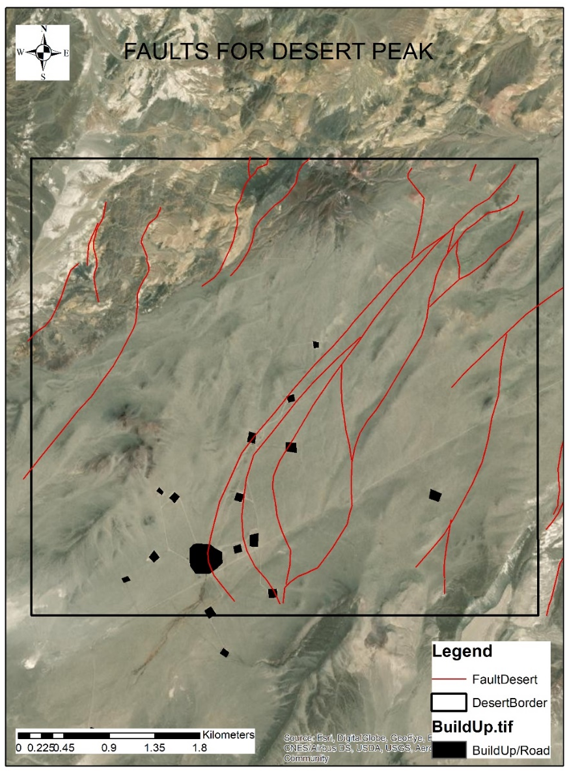
Figure 7. Fault Lines for Desert Peak with AOI.

Figure 8 shows fault density for Desert Peak. Hot colors (red color) show the higher density fault zones.
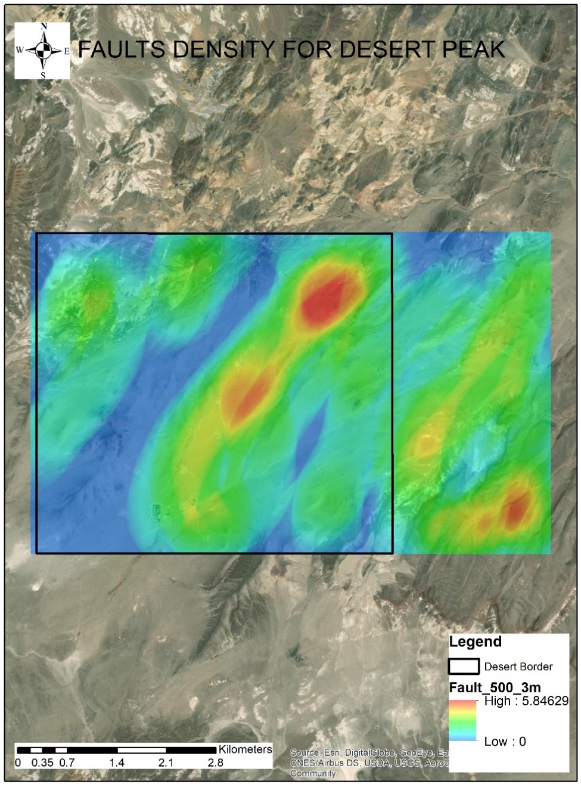
Figure 8. Fault Density for Desert Peak.

    - Fault for Salton Sea
We could not find fault lines for Salton Sea geothermal field. Although, Brawley Seismic Zone (Wallace, 1990) passes through some part of the Salton Sea geothermal field, it does not cover the whole field. Therefore, it is useless with this coverage and values for SOM, SVM and AI. This is another reason that this geothermal field is not suitable for AI implementation for geothermal exploration. This seismic zone is a linear with up to 10 km wide associated with the right-step between the Imperial and San Andreas faults (Treiman, 1999). It can be downloaded from https://hub.arcgis.com/datasets/cadoc::brawley-seismic-zone-local/data web site.
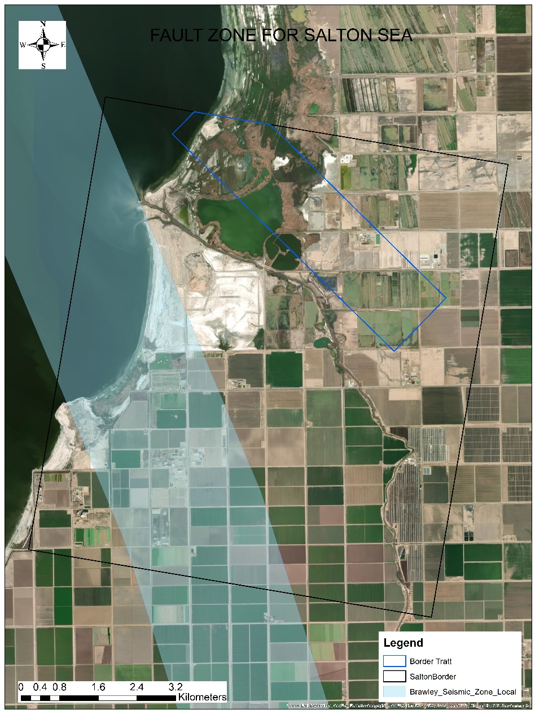
Figure 9. Fault for Brady with AOI.

  - Seismic Data for Brady
Figure 10 shows the seismic data points for Brady. We have seismic data from 50 to 450 m depth. We created a density map of 50-450 m; however, we used the 50 m density map since it was the nearest data points to the surface.
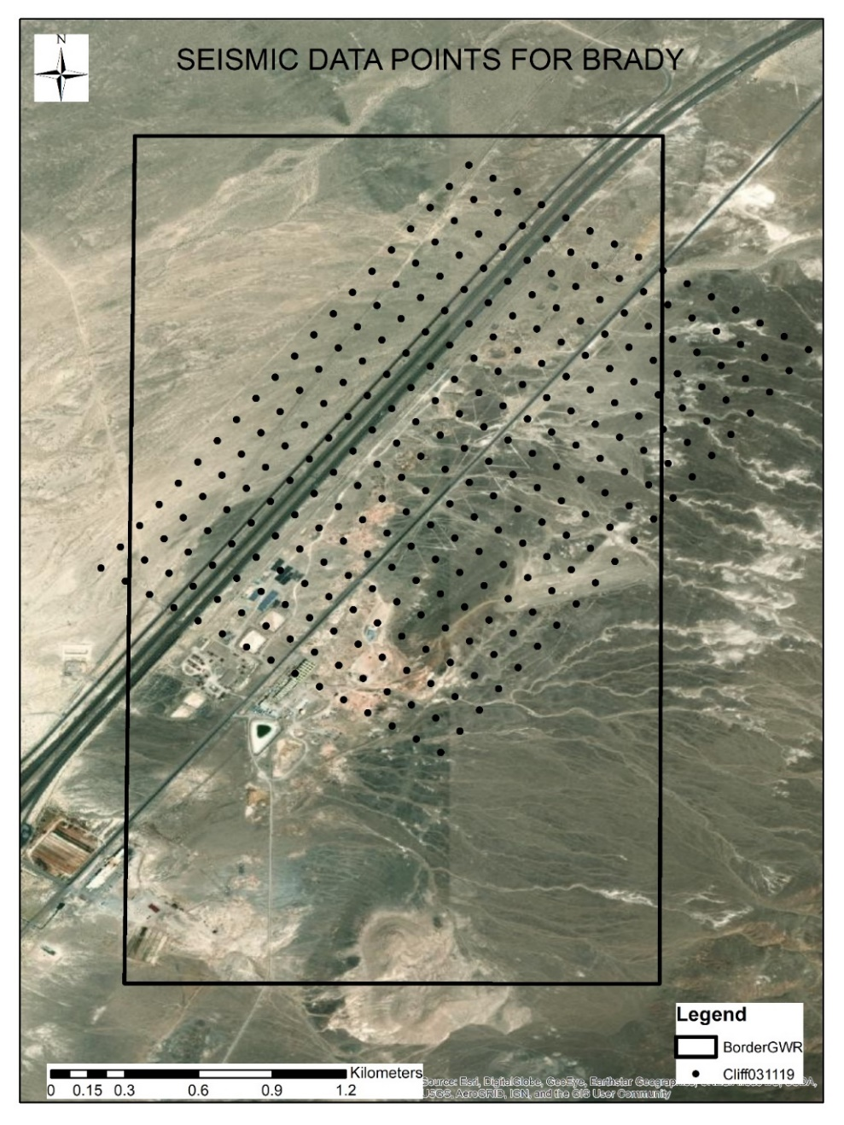
Figure 10. Seismic Data for Brady.

We use the ArcGIS 10.5 “Point Density” function to create a point density map from seismic point data. We defined the cell size and radius of the circle like as we did in line density map. For this map, we have selected 500 m as radius and 3x3m as output cell size. Figure 11 shows the seismic density map for Brady. As it clear that from this figure, the dense zones (red color) overlapped with some other indicators like LST, displacement and wells’ data in the geothermal field.
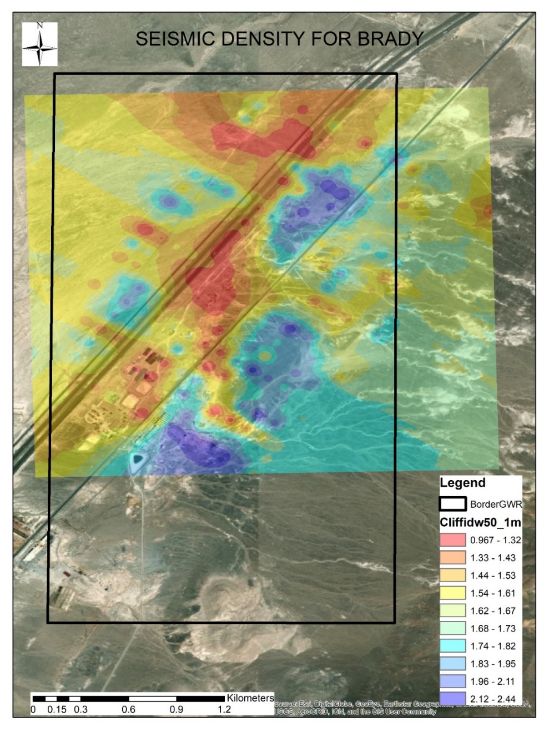
Figure 11. Seismic Density Map for Brady.

  - DTS Data for Brady
Figure 12 shows the DTS surface map for Brady. It is point type and shapefile format. It can be downloaded from https://gdr.openei.org/submissions/958 website. We use this data for verification of the LST analysis by comparing LST results.
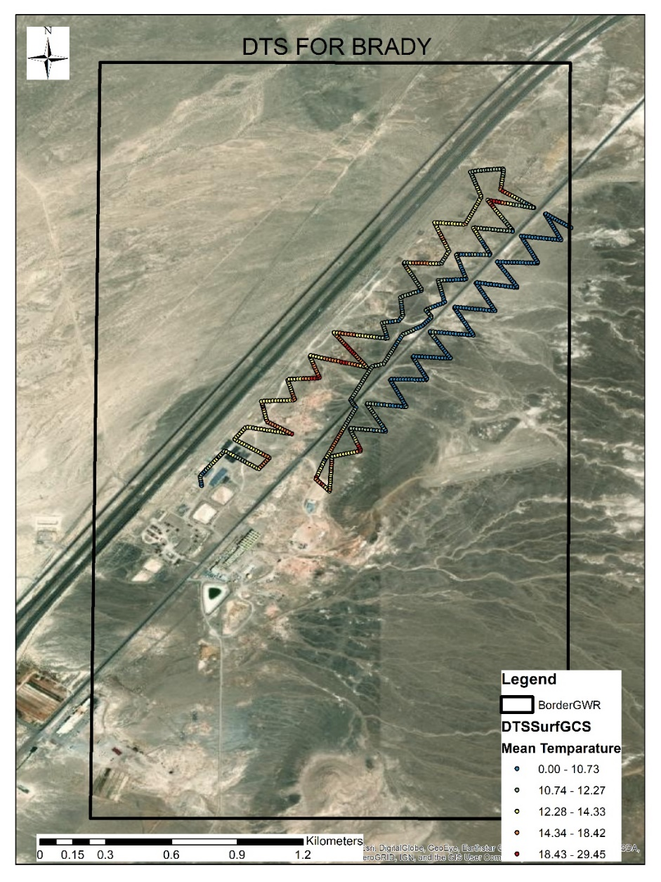
Figure 12. DTS Surface for Brady

- RESULTS and CONCLUSION
In short, fault density is one of the indicators that can be input for SVM, SOM and AI algorithms. As it was mentioned above, fault lines are available for Brady and Desert Peak and we used them for creating fault density map by using line density function. These density maps are input for SVM, SOM and AI for exploration of the geothermal. We use these layers as input for AI and they worked successfully. However, fault zone for Salton Sea does not cover the whole region and just passes some part of the geothermal field. For that reason, it was not possible to create a density map by using this zone. We developed an AI algorithm with several layers including fault zone. The AI algorithm did not work with a missing layer like fault zone successfully.
We explained wells locations for Brady and Salton Sea in this report. Well locations were not being used directly for analysis purposes, but they were useful to understand, compare and verify the rest of the analysis. Not only wells location but also seismic data, DTS data have been used for verification of some other layers like LST.

REFERENCES
- Morphology Literature, (2019). https://drive.google.com/drive/folders/17BRJ92utGMOZCrQERRJpvAUjGWgtAtzU?usp=sharing
- Minster, J. & Jordan, T., 1987. Vector constraints on western U.S. defor- mation from space geodesy, neotectonics and plate motions, J. geophys. Res., 92, 4798–4804.
- P´erouse, E. & Wernicke, B.P., 2017. Spatiotemporal evolution of fault slip rates in deforming continents: the case ofthe Great Basin region, northern Basin and Range province, Geosphere, 13(1), 112.
- Benoit, W.R., Hiner, J.E. & Forest, R.T., 1982. Discovery and geology of the Desert Peak geothermal field: a case history, Tech. Rep., Bulletin 97, Nevada University.
- Faulds, J., Moeck, I., Drakos, P. & Zemach, E., 2010a. Structural as- sessment and 3D geological modeling of the Brady’s geothermal area, Churchill county (Nevada, USA): a preliminary report, in 35th Workshop on Geothermal ReservoirEngineering, StanfordUniversity, Stanford, CA.
- Jolie, E., Moeck, I. & Faulds, J.E., 2015. Quantitative structural–geological exploration of fault-controlled geothermal systems—a case study from the Basin-and-Range Province, Nevada (USA), Geothermics, 54, 54–67.
- Laboso, R.C. & Davatzes, N., 2016. Fault-controlled damage and perme- ability at the Brady geothermal system, Nevada, USA, in Proceedings of the 41st Workshop on Geothermal Reservoir Engineering, Stanford University, Stanford, CA.
- Lim, D. (2016, March 13). Geothermal Data Repository (GDR). Retrieved October 27, 2020, from https://gdr.openei.org/submissions/828
- “Help.” How Line Density Works-Help | ArcGIS for Desktop, desktop.arcgis.com/en/arcmap/10.3/tools/spatial-analyst-toolbox/how-line-density-works.htm.
- Wallace, R. E. (1990). The San Andreas fault system. Washington, D.C.: U.S. G.P.O.)
- Treiman, J.A., compiler, 1999, Fault number 124, Brawley Seismic Zone, in Quaternary fault and fold database of the United States: U.S. Geological Survey website, https://earthquakes.usgs.gov/hazards/qfaults, accessed 10/27/2020 11:01 PM.
- Ali, S. T. et al. (2016) ‘Time-series analysis of surface deformation at Brady Hot Springs geothermal field (Nevada) using interferometric synthetic aperture radar’, Geothermics. CNR-Istituto di Geoscienze e Georisorse, 61, pp. 114–120. doi: 10.1016/j.geothermics.2016.01.008.
- Moeck, I. S. (2014) ‘Catalog of geothermal play types based on geologic controls’, Renewable and Sustainable Energy Reviews. Elsevier, 37, pp. 867–882. doi: 10.1016/j.rser.2014.05.032.
- Villamor, P. et al. (2015) ‘New Zealand Geothermal Power Plants as Critical Facilities : an Active Fault Avoidance Study in the Wairakei Geothermal Field , New Zealand’, (April), pp. 19–25.

